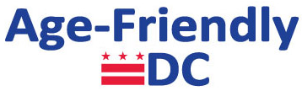

Age-Friendly DC Task Force Meeting
Thursday, July 31, 2013, 3:00-5:00PM
John A. Wilson Building – Room 527
1350 Pennsylvania Ave NW

Agenda

- Welcome: | Facilitation by Deputy Mayor BB Otero
- Action Item: | Approval of April 24th Task Force Meeting Notes
- Action Item: | Approval of DRAFT Age-Friendly DC by 2017 Strategic Plan Goals and Objectives
- Information: | Age-Friendly DC Business Initiative Progress Report
- Closing: | Next steps and adjourn
Next meeting: | Date: Thursday, September 18, 2014, 3-4:30pm  Location: George Washington University (Room TBA)  Agenda: Approval of Age-Friendly DC by 2017 Strategic Plan

