ADVISORY BOARD ON VETERANS AFFAIRS
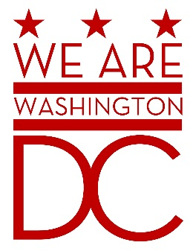
MEETING AGENDA
Tuesday, 5 April 2016
441 4th Street NW
One Judiciary Square – Old Council Chambers
Washington DC 20001
6:30 – 8:00 p.m.

- Call to Order
- Pledge of Allegiance
- Advisory Board Members Roll Call
- Agenda
- Approval of Minutes
  - See http://www.bega-dc.gov/board-commissions-meetings/mayors-advisory-board-veterans-affairs for audio file. (May be delays in posting due to lack of recording system in meeting room.)
- Special Guests
- Charles W. McCaffrey, MBA, Director, Veterans Business Outreach Center at Community Business Partnership

- Charles Eggleston & Anthony Cancelosi, National Capitol Region, Community Engagement Board

- Carl E. Brown Jr., Executive Director, DCSBDC Network

- Creating Local Partnerships, Department of Labor

- Kristina Kaufmann, Executive Director

- Director’s Report
- #Fightfor15 Raise the Minimum Wage Pledge
- Budget Hearings

- Committee Reports

- Old Business (Chairman)
- New Business (Chairman)
- Public Comment (Maximum 2 minute per person)
- Upcoming (Events/Meetings/Holidays)
2016 Mayor’s Day of Recognition for National and Community Service
Tuesday, April 5, 2016
DC Commission on Arts and Humanities Building
200 I Street, SE
First Floor (Make a right at the Security Desk)
Washington, DC 20003

- Adjournment

