ADVISORY BOARD ON VETERANS AFFAIRS
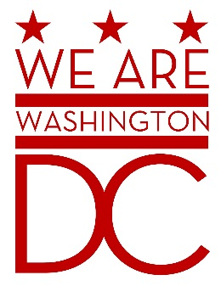

MEETING AGENDA
Tuesday, November 3, 2015

441 4th Street NW
One Judiciary Square Suite 540 South
Washington DC 20001
6:30 – 8:00 p.m.

- Call to Order (Chairman)
- Pledge of Allegiance (Chairman)
- Advisory Board Members Roll Call (Sidney Locks)

- Special Guest (Closed Session)

- Old Business (Chairman)

- New Business (Chairman)

- Public Comment (Maximum 2 minute per person)

- Upcoming (Events/Meetings/Holidays)

- Adjournment (Chairman)

