Empowerment: Providing Parents with the Facts and Tools Necessary
to Provide Healthy, Effective Discipline
Presented by Philip W. Lucas, D.S.W., L.I.C.S.W., L.C.S.W., A.C.S.W,
Past Chair, Mayor’s Advisory Committee on Child Abuse and Neglect (MACCAN)
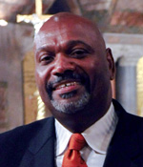

- Learn Corporal Punishment Basics
- Learn Alternatives to Corporal Punishment

(1 CEU credit available pending final approvals)

sponsored by the
DC Mayor’s Advisory Committee on Child Abuse and Neglect (MACCAN).

Tuesday, March 29, 2016
11:00 am to noon

at the
DC Child and Family Services Agency (CFSA)
200 I St SE, Washington, DC 20003
Room 1001
(Please arrive early to allow for building security procedures)

