FOR IMMEDIATE RELEASE
November 12, 2024
BEGA Releases Quarterly Complaint Summary Report for FY2024 Quarter Three
The District of Columbia Board of Ethics and Government Accountability (“BEGA”) today released its Quarterly Complaint Summary Report for the fourth quarter of FY 2024, covering the period from July 1, 2024 through September 30, 2024.
During FY2024 Q4, the Office of Government Ethics (“OGE”), an office within BEGA that investigates alleged violations of the District’s Code of Conduct by employees and public officials, closed 84 matters. Forty percent of the matters closed during this quarter (34 out of 84 matters) involved allegations that were outside of BEGA’s jurisdiction.
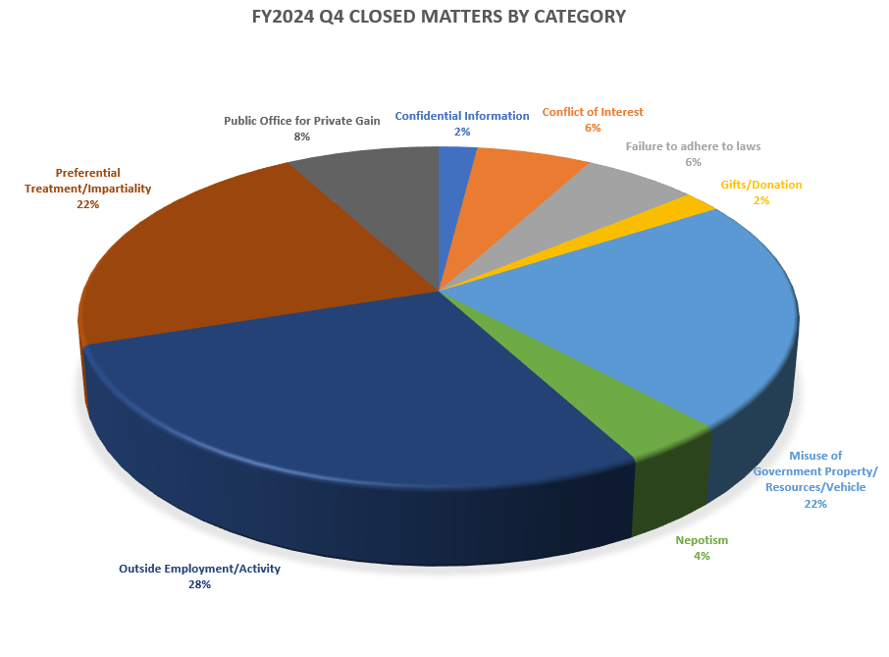
For the 50 closed matters within BEGA’s jurisdiction, allegations related to potential violations of the rules governing outside employment or activities topped the list, accounting for 14 matters (28%). Allegations of preferential treatment and lack of impartiality and misuse of government resources accounted for 11 matters (22%) each while 4 matters (8%) involved allegations of using public office for private gain. Rounding out the list were alleged violations of the conflict of interest rules and failure to adhere to federal, state, and local laws and regulations at 3 matters each (6%), 2 matters (4%) alleging violations of the nepotism rules, and violations of the gifts rules and use of confidential information with one matter each (2%).
Code of Conduct Category | Number | Percent
Outside Employment/Activity | 14 | 28%
Preferential Treatment/Impartiality | 11 | 22%
Misuse of Government Property/Resources/Vehicle | 11 | 22%
Public Office for Private Gain | 4 | 8%
Failure to adhere to all federal, state, and local laws and regulations | 3 | 6%
Conflict of Interest | 3 | 6%
Nepotism | 2 | 4%
Confidential Information | 1 | 2%
Gifts | 1 | 2%

The summary of closed matters and additional information can be found on BEGA’s Ethics Heatmap (https://bega.dc.gov/page/ethics-heatmap), which will be updated with additional data as it is available.

